File permissions in Linux

Project description
Using Linux commands to manage file permissions. I mainly work with the research team as a security professional at a large organization. Part of my job is to ensure users on this team are authorized with the appropriate permissions. This helps keep the system secure.
My task is to examine existing permissions on the file system to determine if the permissions match the authorization that should be given. If they do not match, modify the permissions to authorize the appropriate users and remove any unauthorized access.

Check file and directory details
The ls -l command in Linux provides a detailed listing of files and directories, showing permissions, number of links, owner, group, size, and the date and time of the last modification. ls -la is used to list files in a long format, including permissions, number of hard links, owner name, group name, size in bytes, timestamp, and the file name, including hidden files.
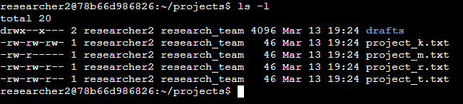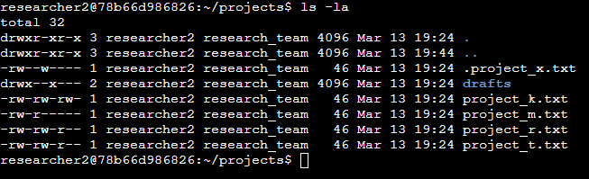

Describe the permissions string
A 10-character string begins each entry and indicates how the permissions on the file are set. For instance, a directory with full permissions for all owner types would be drwxrwxrwx

- The 1st character indicates the file type. The d indicates it’s a directory. When this character is a hyphen (-), it's a regular file.
- The 2nd-4th characters indicate the read (r), write (w), and execute (x) permissions for the user. When one of these characters is a hyphen (-) instead, it indicates that this permission is not granted to the user.
- The 5th-7th characters indicate the read (r), write (w), and execute (x) permissions for the group. When one of these characters is a hyphen (-) instead, it indicates that this permission is not granted for the group.
- The 8th-10th characters indicate the read (r), write (w), and execute (x) permissions for the owner type of other. This owner type consists of all other users on the system apart from the user and the group. When one of these characters is a hyphen (-) instead, that indicates that this permission is not granted for other.

Change file permissions
The organization does not allow others to have write access to any files. I used the command
ls -la to list all files, including hidden files to see if others had write access to any file. It turned out that the project_k.txt file was giving access so I used the chmod (change mode/permissions) command to remove access. chmod is used to control access to files and directories, ensuring that sensitive data is inaccessible to unauthorized users while still allowing necessary operations to occur.

chmod o-w project_k.txt
File project_m.txt also needed the read access removed for the group.
chmod g-r project_m.txt
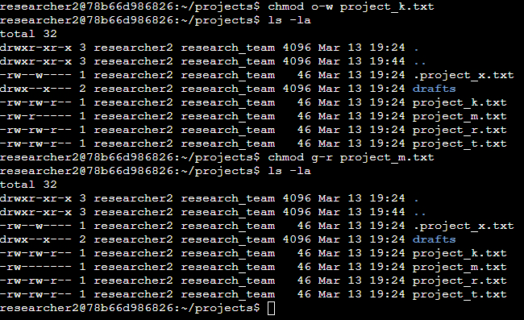

Change file permissions on a hidden file
The research team has archived .project_x.txt, which is why it’s a hidden file. This file should not have write permissions for anyone, but the user and group should be able to read the file. When I checked the file using ls -la, the user and group had write permissions, but the group did not have read permissions. So I used the chmod command to fix the situation.

chmod u-w,g-w,g+r .project_x.txt

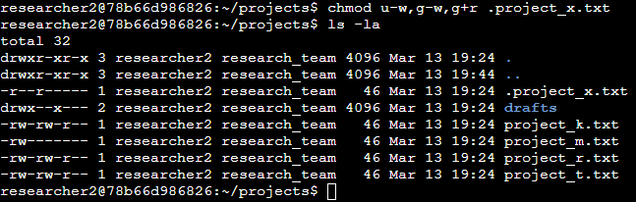

Change directory permissions
The files and directories in the projects directory belong to the researcher2 user. Only researcher2 should be allowed to access the drafts directory and its contents. When I checked, the group had execute permissions so I removed their access.
chmod g-x drafts

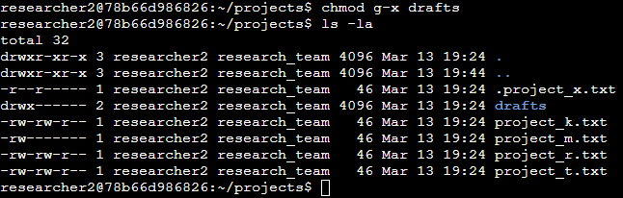

Summary
There were curtain files that needed to remove access permissions and curtain files that needed to add access permissions. I used the ls -la command to list all files to see who had access and who needed access. I then use the chmod command to apply the correct permissions. By mitigating these access controls, this ensures that users on the team are authorized with the appropriate permissions to help the system stay secure and maintain least privilege access.

Joel Massicot
ISC2 CC (Certified in Cybersecurity)
joel.massicot@zohomail.eu | 857-788-3808


